Step 1. Automated Unit Testing
Step 2. Refactoring
Step 3. Automated Building

Executive Summary
The unavoidable code changes degrade the quality of initial software design. Therefore, developers need to be able to redesign as they change the code to keep the quality of software. Refactoring is the process of changing the code while improving its internal structure and minimizing the chance of introducing bugs at the same time. Refactoring tool provides an easy and fast way to apply various, sometimes complicated, refactoring techniques.

Introduction
By now, hopefully, you are ready to implement or already created, some unit tests, which is essential before you make any code change since those tests will verify that your changes will not break existing logic. When you do make a change, you want to make it right. Otherwise, you will get in trouble after a couple of changes; duplicated codes are all over the places, it becomes difficult to understand the code, further changes take more time, once appear to be simple change becomes nightmare. As a result, developers become uncomfortable making changes. In order to avoid troubles, you need a systemic approach to change your codes.

What is Refactoring anyway?
The famous Refactoring book [Fowler2000, preface] defines it well and I shall quote, “the process of changing a software system in such a way that it does not alter the external behavior of the code yet improves its internal structure. It is a disciplined way to clean up code that minimizes the chances of introducing bugs.”

Why Refactoring?
The book [Fowler2000, preface] also mentions the important point regarding software development, “Over time the code will be modified, […] The code slowly sinks from engineering to hacking. […] With Refactoring you can take a bad design, chaos even, and rework it into well-designed code. […] You find that design, rather than occurring all up front, occurs continuously during development.”
In other words, the inevitable code changes degrade the quality of initial software design. Developers need to be able to redesign as they change the code, to keep the integrity of software, the technique called, Refactoring.

Introducing Refactoring Tool
The Refactoring book [Fowler2000] introduces over 70 refactoring techniques and every one of them is worth reading and applicable to your day to day programming and designing. However, remembering all will be another challenge and applying them is not an easy task. Remember the time when you know you were introducing duplication by copy & paste and left with a bad feeling (because of the tight schedule)? Hence, mere mortals like us need some help, the tool. Visual Studio 2005 (VS2005) introduces a handful of them and hopefully, they provide more in the future. ReSharper 2.0 from JetBrains (http://www.jetbrains.com) provides about 27 refactorings.

Introducing Frequently Used Refactorings with Example
I will explain some frequently used techniques from Fowler’s book, with the example code that I created for Step 1. Unit Testing using ReSharper tool. You can follow the steps that I took with VS2005 provided refactoring features, although number of refactorings are limited. I will explain those features in both tools side by side when they overlap. Even if you do not have ReSharper or VS2005, you can still follow this example by making some manual code changes. I will try to make code changes obvious so that you can easily follow even without those tools. In the end, learning Refactoring is more important than knowing tools. I will be using .net 2.0 syntax but you can use the .net 1.1 syntax with slight code change. Download the example code at the previous article here, if you don’t have it yet and you can find the final example here for reference. You need to convert the Visual Studio 2003 (VS2003) project file in the previous example to VS2005 one, if you want to use VS2005. Keep in mind that this is a fictional situation that I created for the series.

* Requirement Change #1: Add a functionality to calculate interest based on the average daily balance and deposit that interest to the customer’s account monthly.

Let’s first make all the tests pass by un-commenting codes in Withdraw method, compile and run all the unit tests and watch all tests pass. (Tip: If you have the ReSharper it has a menu to run all the unit tests in a solution with automatic compiling.)
Now look at the code. The private variable name, _amount begs to be changed. Since we are dealing with account’s balance, I think _balance is better name for it.

Rename – The name does not reveal its purpose -> Change the name. [Fowler2000]

Good name for a variable, method or any symbol is important to quickly understand its purpose. Some people even think that naming a class and its interfaces is more important than writing hundreds of lines of codes! Also, try to name them meaningful to human not the computer.
VS2005 has rename refactoring. It searches the comment and string literals for renaming the symbol and gives you the preview of the result. Place the cursor over _amount and click the rename menu under Refactor menu and type the new name into the dialog.

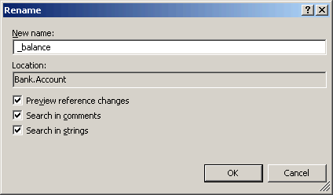

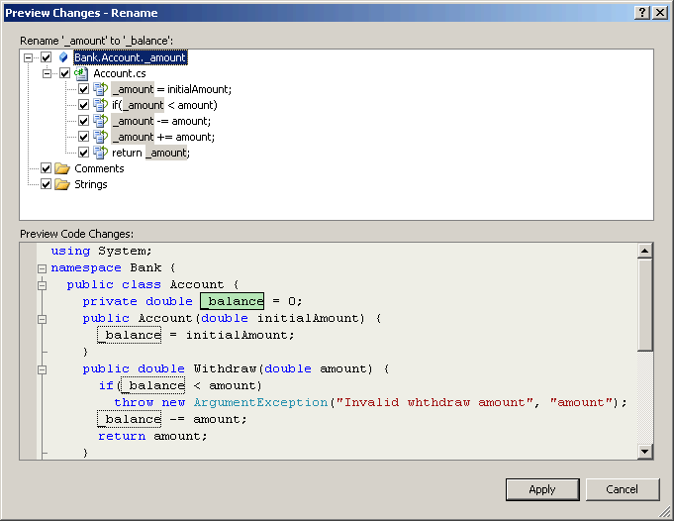

ReSharper lets you change the name of variable, method, class, etc., everywhere it is being referenced in the solution automatically. It even allows you to change the name in the comment and string literal, referencing variable name, and the filename if you change the class name.

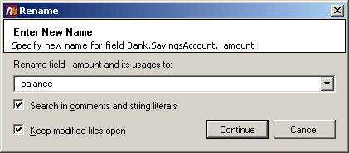

Run unit tests and watch they pass.

Now we need a method, ProcessMonthlyInterest which processes monthly interest using daily balance history. In order to do that, we need another method to snapshot daily balance, SnapShotDailyBalance which will be called by daily settlement processing job. Add below codes for this purpose to the Account class. Please note that interest rate is coming from outside since account does not know the current interest rate.

private List<double> _dailyBalanceHistory = new List<double>();
public void SnapShotDailyBalance() {
_dailyBalanceHistory.Add(_balance);
}
public void ProcessMonthlyInterest(double interestRate) {
double balanceSum = 0;
_dailyBalanceHistory.ForEach(delegate(double dailyBalance) { balanceSum += dailyBalance; });
double averageDailyBalance = _dailyBalanceHistory.Count > 0 ? balanceSum / _dailyBalanceHistory.Count : 0;
Deposit(averageDailyBalance * interestRate);
_dailyBalanceHistory.Clear();
}

You need to modify this code slightly if you are following this article with VS2003.
We need tests to verify if these new methods are doing the right thing. Add TestSnapShotDailyBalance, TestProcessMonthlyInterest methods to TestAccount class. Optionally, you can use NUnitGenAddIn tool to generate those test stubs if you installed it. In addition to that, we need to create DailyBalanceHistory internal get property to Account for testing result. Sometimes, you need to make a property or method available for unit test only. However, making them “public” breaks the encapsulation principle of the class. Hence, internal modifier is appropriate for this case. The important thing is that these two test methods now become clients of Account class simulating daily processing and monthly processing jobs accordingly.

[SetUp]
public void SetUp() {
_unitUnderTest = new Account(100);
}
[TearDown]
public void TearDown() {
_unitUnderTest = null;
}
[Test()]
public void TestSnapShotDailyBalance() {
_unitUnderTest.Deposit(50); _unitUnderTest.SnapShotDailyBalance();
Assert.AreEqual(150, _unitUnderTest.DailyBalanceHistory[0]);
_unitUnderTest.Withdraw(45); _unitUnderTest.SnapShotDailyBalance();
Assert.AreEqual(105, _unitUnderTest.DailyBalanceHistory[1]);
}
[Test()]
public void TestProcessMonthlyInterest() {
double interestRate = 0.025;
TestSnapShotDailyBalance();
_unitUnderTest.ProcessMonthlyInterest(interestRate);
Assert.AreEqual(108.1875, _unitUnderTest.GetBalance());
}

Run these unit tests and watch they pass.

* Requirement Change #2: Apply higher interest rate for accounts with good standing – old account with high average daily balance.

We need new field representing “account created date” and new constructor to pass in the created date like below.

private DateTime _createdDate;
public Account(double initialAmount) {
_balance = initialAmount;
_createdDate = DateTime.Now;
}
public Account(double initialAmount, DateTime createdDate) : this(initialAmount) {
_createdDate = createdDate;
}

We have to change the logic in ProcessMonthlyInterest method. It would be a lot easier to change if we have a simple method, GetAverageDailyBalance.

Extract Method – You have a code fragment that can be grouped together -> Turn the fragment into a method whose name explains the purpose of the method. [Fowler2000]

Obviously, if the method is too long you want to break it into chunks to facilitate readability and reusability. It would be even better if you can make high level method to contain just a couple of methods calls to make clear what it is doing.
VS2005 gives you a very convenient way to extract method. You can just select the part of the method body and click menu and then it will automatically parse the code, figure out return value and parameters.

[before]
public void ProcessMonthlyInterest(double interestRate) {
double balanceSum = 0;
_dailyBalanceHistory.ForEach(delegate(double dailyBalance) { balanceSum += dailyBalance; });
double averageDailyBalance = _dailyBalanceHistory.Count > 0 ? balanceSum / _dailyBalanceHistory.Count : 0;
Deposit(averageDailyBalance*interestRate);
_dailyBalanceHistory.Clear();
}

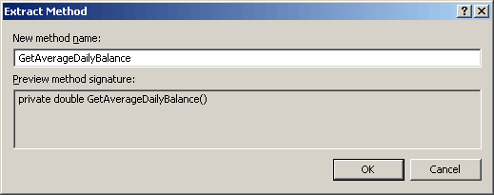

[after]
public void ProcessMonthlyInterest(double interestRate) {
double averageDailyBalance = GetAverageDailyBalance();
Deposit(averageDailyBalance*interestRate);
_dailyBalanceHistory.Clear();
}
private double GetAverageDailyBalance() {
double balanceSum = 0;
_dailyBalanceHistory.ForEach(delegate(double dailyBalance) { balanceSum += dailyBalance; });
return _dailyBalanceHistory.Count > 0 ? balanceSum / _dailyBalanceHistory.Count : 0;
}

ReSharper also gives you similar convenient way to extract method and a dialog box to confirm or change the findings.

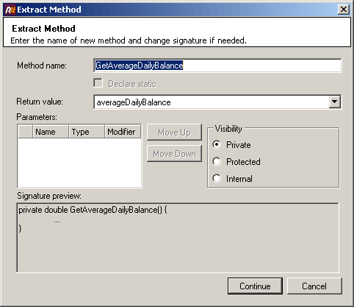

Run unit tests and watch they pass.

Let’s get rid of the temporary variable, averageDailyBalance for clarity.

Inline variable – You have a variable that is assigned to once with a simple expression, and the variable is getting in the way of other refactorings -> Replace all references to that variable with the expression. [Fowler2000]

ReSharper can replace this variable with method name for you.

public void ProcessMonthlyInterest(double interestRate) {
Deposit(GetAverageDailyBalance() * interestRate);
_dailyBalanceHistory.Clear();
}

Run unit tests and watch they pass.

You may have realized by now that you need a keyboard shortcut for running the unit tests (See previous article for setting this up for NUnit-Gui and the menu path for ReSharper is, Tools->Options->Environment->Keyboard->ReSharperAddIn2005.UnitTestRunner.RunAllSolution).

It’s so much clear now to change this method to have following conditional processing.

public void ProcessMonthlyInterest(double interestRate) {
if (GetAverageDailyBalance() > 50000
&& (DateTime.Now - _createdDate).Days > 365 * 5)
Deposit(GetAverageDailyBalance() * (interestRate + 0.005));
else
Deposit(GetAverageDailyBalance() * interestRate);
_dailyBalanceHistory.Clear();
}

We need to modify the unit test to cover the logic that we just changed. That condition was simple to implement while it is not that simple to modify the test since we need to consider every possible cases for new condition. I can think of below four cases.

- New account with low average daily balance
- New account with high average daily balance
- Old account with low average daily balance
- Old account with high average daily balance

You can copy modified test code from the final sample. Look for commented section starting “Initial version of TestProcessMonthlyInterest()”. Have a look at the unit test code and see if they make sense to you.

Run unit tests and watch they pass.

The condition that we came up with is not that complicated but you may forget what that condition was for after some time. We can make a descriptive variable to replace it. (If this condition is being used by many other places, we can extract a reusable method, instead.)

Introduce variable – You have a complicated expression -> Put the result of the expression, or parts of the expression, in a temporary variable with a name that explains the purpose. [Fowler2000]

You can increase readability with descriptive local variable instead of complicated expression, especially when that expression is being repeated in the body of method.
With ReSharper, you can just select the expression, bring up the refactoring dialog and type the name of the variable. It will replace any repeating expressions.

[before]
public void ProcessMonthlyInterest(double interestRate) {
if (GetAverageDailyBalance() > 50000
&& (DateTime.Now - _createdDate).Days > 365 * 5)
Deposit(GetAverageDailyBalance() * (interestRate + 0.005));
else
Deposit(GetAverageDailyBalance() * interestRate);
_dailyBalanceHistory.Clear();
}

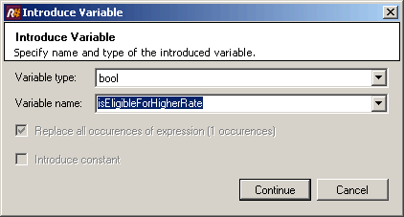

[after]
public void ProcessMonthlyInterest(double interestRate) {
bool isEligibleForHigherRate = GetAverageDailyBalance() > 50000
&& (DateTime.Now - _createdDate).Days > 365 * 5;
if (isEligibleForHigherRate)
Deposit(GetAverageDailyBalance() * (interestRate + 0.005));
else
Deposit(GetAverageDailyBalance() * interestRate);
_dailyBalanceHistory.Clear();
}

Run unit tests and watch they pass.

There are many magic numbers in the code, which draw my attention to further refactoring.

Replace Magic Number with Symbolic Constant - You have a literal number with a particular meaning -> Create a constant, name it after the meaning, and replace the number with it. [Fowler2000]

However, it is now obvious to me that the whole conditional expression is for coming up with proper interest rate, which I originally thought that it should come from the external player and that assumption still holds. Therefore, it is more appropriate to move this logic to new class, InterestController. Let’s take small steps toward that direction:

- Use the same variable for interest rate.
Then, we can get rid of duplicate code.

public void ProcessMonthlyInterest(double interestRate) {
bool isEligibleForHigherRate = GetAverageDailyBalance() > 50000
&& (DateTime.Now - _createdDate).Days > 365 * 5;
if (isEligibleForHigherRate)
interestRate = interestRate + 0.005;
Deposit(GetAverageDailyBalance() * interestRate);
_dailyBalanceHistory.Clear();
}

Run unit tests and watch they pass.

- Extract the logic that decides which interest rate applies depending on condition, into new method.

[before]
public void ProcessMonthlyInterest(double interestRate) {
bool isEligibleForHigherRate = GetAverageDailyBalance() > 50000
&& (DateTime.Now - _createdDate).Days > 365 * 5;
if (isEligibleForHigherRate)
interestRate = interestRate + 0.005;
Deposit(GetAverageDailyBalance() * interestRate);
_dailyBalanceHistory.Clear();
}

[after]
public void ProcessMonthlyInterest(double interestRate) {
interestRate = GetInterestRate(interestRate);
Deposit(GetAverageDailyBalance() * interestRate);
_dailyBalanceHistory.Clear();
}
private double GetInterestRate(double interestRate) {
bool isEligibleForHigherRate = GetAverageDailyBalance() > 50000
&& (DateTime.Now - _createdDate).Days > 365 * 5;
if (isEligibleForHigherRate)
interestRate = interestRate + 0.005;
return interestRate;
}

Run unit tests and watch they pass.

- Now we need to move this new method from the Account class to new class, InterestController.
Unfortunately, there is no tool that supports this kind of refactoring, Extract Class.

Extract Class – You have one class doing work that should be done by two -> Create a new class and move the relevant fields and methods from the old class into the new class. [Fowler2000]

You can do so manually by creating new class and move this method and tweak things here and there. However, it would be great if refactoring tool can support this. So, I requested this important refactoring onto ReSharper forum. Fortunately, you can accomplish this refactoring by combining existing refactoring functionalities. Let’s take small steps and utilize the tool to avoid mistakes.

  - First, make GetInterestRate method static. This will take this method out of the class instance scope, although it is not completely out of scope since it still can access private method. ReSharper lets you introduce a parameter, account.

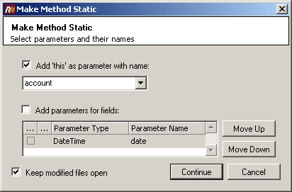

private static double GetInterestRate(Account account, double interestRate) {
bool isEligibleForHigherRate = account.GetAverageDailyBalance() > 50000
&& (DateTime.Now - account._createdDate).Days > 365 * 5;
if (isEligibleForHigherRate)
interestRate = interestRate + 0.005;
return interestRate;
}

Run unit tests and watch they pass.

  - Now it is safe to have interest rate inside this method.
You can use VS2005’s Remove Parameters refactoring for this task. It also supports other parameter related refactorings, Promote Local Variable to Parameter and Reorder Parameter.

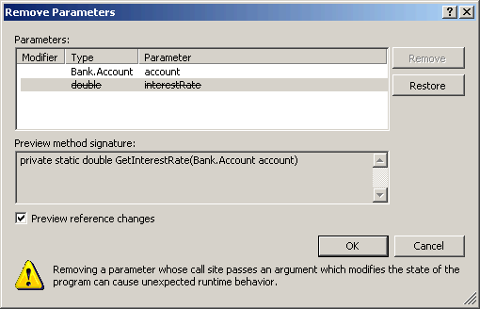

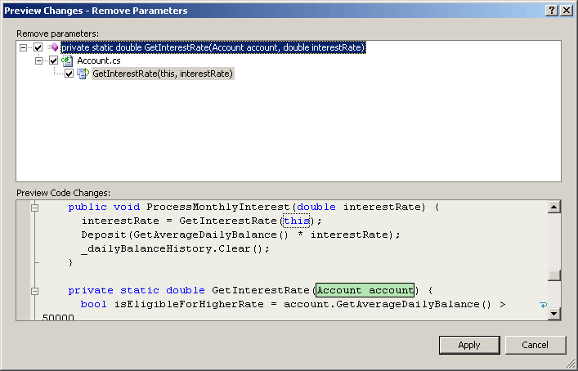

You need to add a line to declare the interest rate inside the method.

private static double GetInterestRate(Account account) {
double interestRate = 0.025;
…
}

ReSharper also lets you change the method signature and provides additional parameter related refactorings, Introduce Parameters and Extract Class from Parameters.

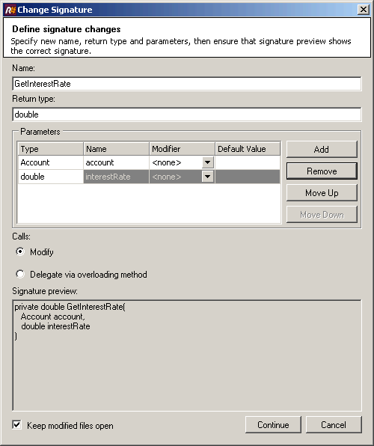

Run unit tests and watch they pass.

  - Before we move this static method to new class, we need to do some work since it is referencing Account class’ private field and method; make GetAverageDailyBalance method public manually and encapsulate _createdDate private field. This time we do not make them internal since they are not for unit tests but for other class.

Encapsulate Field – There is a public field -> Make it private and provide accessors. [Fowler2000]

This is not exactly the case but related to this situation. VS2005 has Encapsulate Field refactoring.

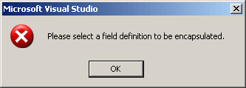
(You need to place the input caret to the definition of the _createdDate.)
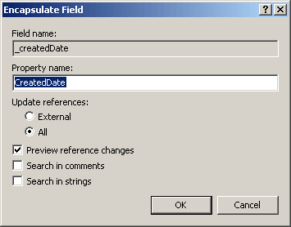
(You need to choose “Update references” to “All” to encapsulate the reference to private field inside the class.)

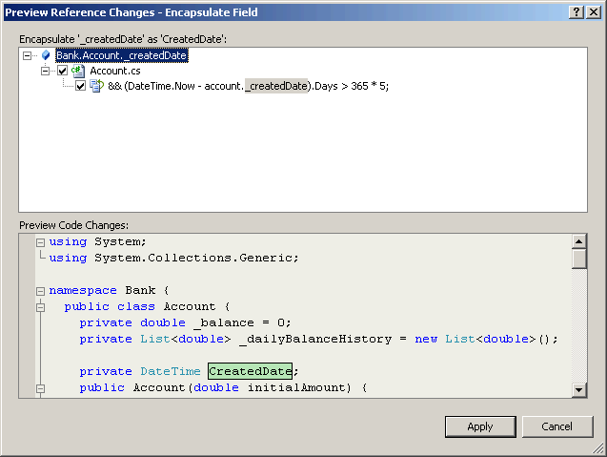

After the refactoring, delete set accessor since we do not need it this time.

private static double GetInterestRate(Account account) {
double interestRate = 0.025;
bool isEligibleForHigherRate = account.GetAverageDailyBalance() > 50000
&& (DateTime.Now - account.CreatedDate).Days > 365 * 5;
…
}

ReSharper also has this refactoring with option to choose whether you want to generate get and/or set accessors.

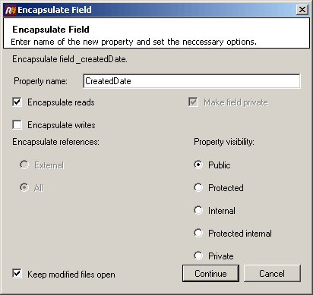

Run unit tests and watch they pass.

  - It is time to create new class, InterestController and move this static method to it.
ReSharper’s Move refactoring can move the static method to another class and the class from one namespace to another or from a file to another as well.

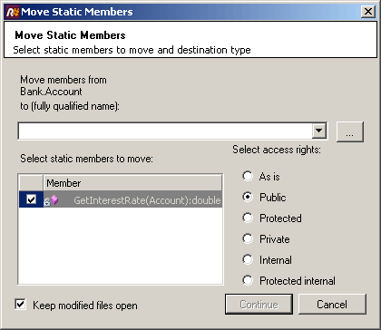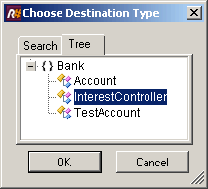

While you are moving this method using ReSharper, you need to choose the destination type and public access right to the method.

Run unit tests and watch they pass.

  - Make static method instance method.
I strongly believe that it is always good to avoid making method static unless it has a specific purpose, for example, methods in factory method pattern [1] or singleton pattern [2]. If you overly use static methods, they will bite you later, especially when you need to make significant changes while there are many client codes using them. Always think of good interfaces or public instance methods that describe class’ purpose well. That way, when you need to make change later, you could minimize the impact on interfaces and introduce changes without affecting existing clients.

[before]
public void ProcessMonthlyInterest(double interestRate) {
interestRate = InterestController.GetInterestRate(this);
…
}

[after]
public void ProcessMonthlyInterest(double interestRate) {
interestRate = new InterestController().GetInterestRate(this);
…
}

Run unit tests and watch they pass.

You have successfully extracted a new class, InterestController out of the Account class!

- It is time to delete the line inside ProcessMonthlyInterest method.
It is because the interest rate has to come from outside.

public void ProcessMonthlyInterest(double interestRate) {
//interestRate = new InterestController().GetInterestRate(this);
Deposit(GetAverageDailyBalance() * interestRate);
_dailyBalanceHistory.Clear();
}

Run unit tests and watch they fail.

It fails because the correct interest rate has to be provided by the outside player, unit test, which is not the case here.

- Change the unit test, TestProcessMonthlyInterest to make it pass.
It would be a good idea to create another unit test for GetInterestRate. However, it is perfectly safe to keep combined tests in TestProcessMonthlyInterest. You will have a chance to extract different test context out of this unit test when you need to change GetInterestRate later. You can find the revised unit test code in the final sample. Look for commented section starting “Revised version of TestProcessMonthlyInterest()”.

Run unit tests and watch they pass.

- Let’s replace magic number with constant or variable in GetInterestRate now.
ReSharper provides Introduce Fields and Introduce Variable refactorings accordingly.

public double GetInterestRate(Account account) {
double interestRate = 0.025;
double highInterestRate = interestRate + 0.005;
int thresholdBalance = 50000;
int thresholdDays = 365 * 5;
bool isEligibleForHigherRate = account.GetAverageDailyBalance() > thresholdBalance
&& (DateTime.Now - account.CreatedDate).Days > thresholdDays;
return isEligibleForHigherRate ? highInterestRate : interestRate;
}

Run unit tests and watch they pass.

* Requirement Change #3: Introduce two checking account types, one with interest and the other without.

There comes another change!
First thing’s first. We need to change the name of the type, Account since this name does not hold the correct meaning anymore. SavingsAccount would be good name for it.
VS2005’s Rename refactoring can change the class name.

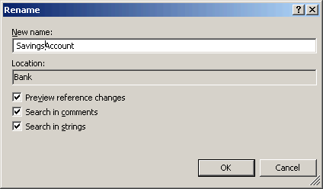

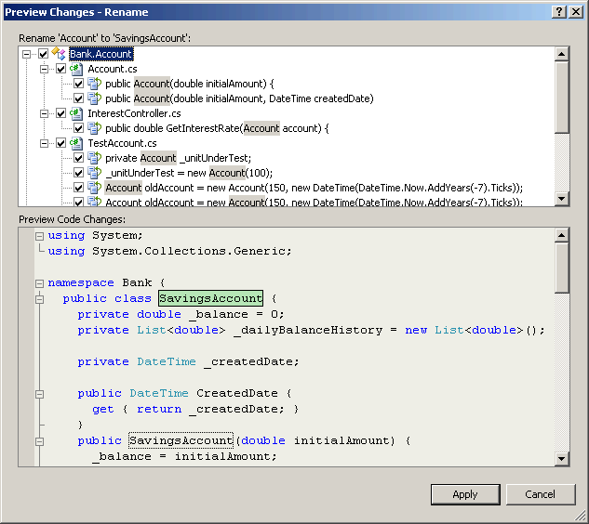

Change the filename to SavingsAccount.cs.
ReSharper’s Rename refactoring also can rename the class.

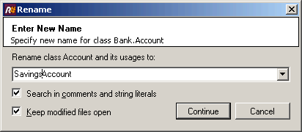

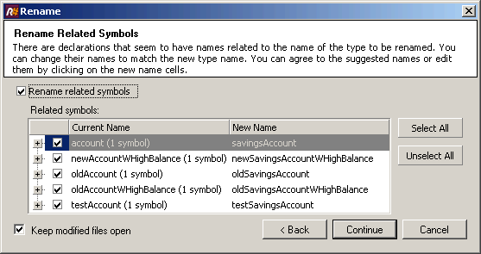
(Let ReSharper change all the related variable names.)

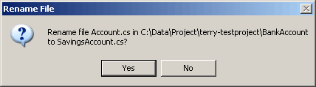
(Change the code filename also.)

You could copy existing similar routines from SavingsAccount to create CheckingAccount and InterestCheckingAccount class to accomplish the requirement change quickly. However, this notorious copy & paste technique will get you in trouble when you need to change the common routine later; you have to change two places or even three! Instead, you can extract a super class, Account from existing class along with common implementation.

Extract Superclass – You have two classes with similar features -> Create a super class and move the common features to the super class. [Fowler2000]

ReSharper cannot extract super class from two or more classes. Instead, you can extract a super class from one class and then change other classes manually to inherit that class. In this case, you can just extract super class and create new types from it.

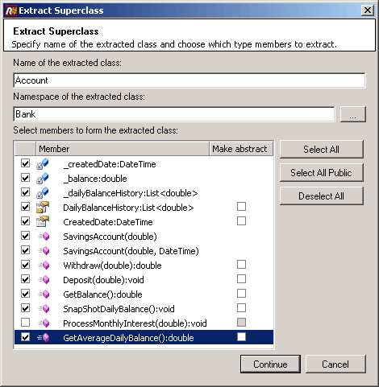
(Choose anything common for derived classes. While extracting you can choose to “use base types where possible” feature so that ReSharper can change any references to SavingsAccount into those to Account.)

We need to make Account abstract class since there should be no instance of Account available.

Run unit tests and watch they pass.

Now we are ready to introduce new types. You can think of many ways to introduce this hierarchy of four types with interest processing for SavingsAccount and InterestCheckingAccount. Below is the hierarchy that I can think of without interest processing in InterestCheckingAccount.

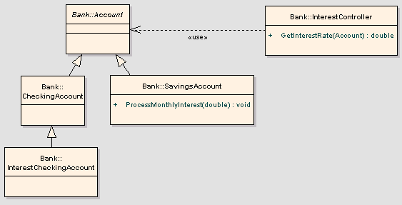

Let’s create them first.

public class CheckingAccount : Account {
public CheckingAccount(double initialAmount) : base(initialAmount) {}
public CheckingAccount(double initialAmount, DateTime createdDate) : base(initialAmount, createdDate) {}
}
public class InterestCheckingAccount : CheckingAccount {
public InterestCheckingAccount(double initialAmount) : base(initialAmount) {}
public InterestCheckingAccount(double initialAmount, DateTime createdDate) : base(initialAmount, createdDate) {}
}

For the interest processing, the simple way to implement can be adding a flag attribute to the Account class, indicating whether the interest has to be processed on the instance under consideration. However, there is another way to indicate this on the type level, interface type.

Extract Interface – Several Clients use the same subset of a class’ interface, or two classes have part of their interfaces in common -> Extract the subset into an interface. [Fowler2000]

Interface gives you the ability to eliminate implementation dependency and separate concerns from the type hierarchy. When you need to use certain interface(s) with varying implementations across multiple types, referencing only the interface(s) is the way to go. For example, when you need to write some content in various outputs, you need to know only the interface, Write, regardless of the actual implementation of each concrete objects – whether it writes the content to html, xml. pdf or plain text file. You can implement this interface concept with abstract class and interface type in .net. For our example, we can introduce IInterestProcessable interface type with related interfaces so that we can separate the interest processing concern from other account related concern. Here is the revised structural diagram.

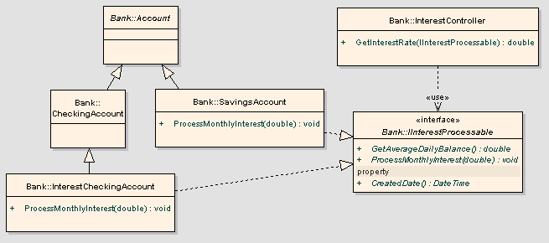

ReSharper’s implementation is similar to Extract Superclass explained before, leaving the implementation. You need to extract interface from SavingsAccount since it has all the interfaces we want to extract and check the “Include members from base classes” option.

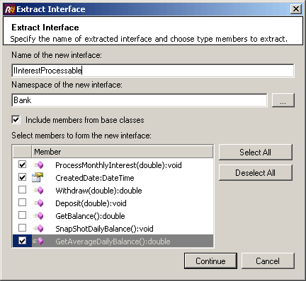

Run unit tests and watch they pass.

Now implement this interface in InterestCheckingAccount by copying ProcessMonthlyInterest from SavingsAccount. Note that we do not need to implement other interfaces since Account base class implements those for us already.

public class InterestCheckingAccount : CheckingAccount, IInterestProcessable {
public InterestCheckingAccount(double initialAmount) : base(initialAmount) {}
public InterestCheckingAccount(double initialAmount, DateTime createdDate) : base(initialAmount, createdDate) {}
public void ProcessMonthlyInterest(double interestRate) {
Deposit(GetAverageDailyBalance()*interestRate);
_dailyBalanceHistory.Clear();
}
}

We can safely change the InterestController’s dependency on Account type to one on IInterestProcessable type. Now it can handle any types that implement this interface type, namely SavingsAccount and InterestCheckingAccount in our example.

Run unit tests and watch they pass.

However, existing unit tests do not cover the ProcessMonthlyInterest method in InterestCheckingAccount. For that, you can either copy and paste the existing TestProcessMonthlyInterest into new unit test, revise existing one to test both SavingsAccount and InterestCheckingAccount, or we can refactor it by moving the test to the IInterestProcessable level and extracting the test for GetInterestRate to the InterestController level. I prefer the last approach since this is a good chance to break the heavy unit tests into more manageable ones. You can find the refactored unit test code in the final sample, TestAccountBase.cs, TestIInterestProcessable.cs, and TestInterestController.cs.

Run unit tests and watch they pass.

Congratulations! You just accomplished three requirement changes while improving the design utilizing Refactoring techniques at the same time!

Things to Remember and The Next Step
Here are some points that you should remember.
  - Create unit tests when you make any changes.
  - Remove duplicated codes and promote reusability.
  - Take small steps while you are making changes.
  - Do not wait until it gets out of control.
  - Run unit tests every time you make changes.
  - Finally, keep improve codes using refactoring as you make changes.

With the help of unit test framework and refactoring tool, changing codes the right way becomes pretty easy thing to do. The key idea is that you keep the rhythm of this cycle; creating unit tests, refactoring and changing, running unit tests, in a day to day coding.
Advanced readers may want to read a book, “Refactoring To Patterns” by Joshua Kerievsky. Without thinking of design patterns, Refatoring gives you limited amount of design change. With it, you will find the beautifully re-designed or even re-architected software.
The next and final step, Automated Build will give you fast, aggregated feedback of software development cycle, usually out of coordinated efforts, closing the loop of the continuous rhythm as well as relief from the pain of manual build process.

Reference
[Fowler2000] Refactoring – Improving the Design of Existing Code by Martin Fowler, Addison-Wesley 2000

